Project Design Phase-II
Technology Stack (Architecture & Stack)
Date | 01 September 2026
Team ID | Individual Project
Project Name | Software Installation Request Automation in ServiceNow
Maximum Marks | 4 Marks
Technical Architecture:
The deliverable includes the architectural diagram and the information in Table-1 and Table-2, adapted to the ServiceNow software installation request automation project.
Example: Software installation request processing through ServiceNow Service Catalog and Workflow/Automation
Reference: https://developer.ibm.com/patterns/ai-powered-backend-system-for-order-processing-during-pandemics/
Guidelines:
- Include all the processes as application logic / technology blocks.
- Provide infrastructural demarcation (ServiceNow instance / cloud platform).
- Indicate external interfaces (External API: N/A for the core solution).
- Indicate data storage components / services.
- Indicate interface to machine learning models: N/A because no ML model is used.
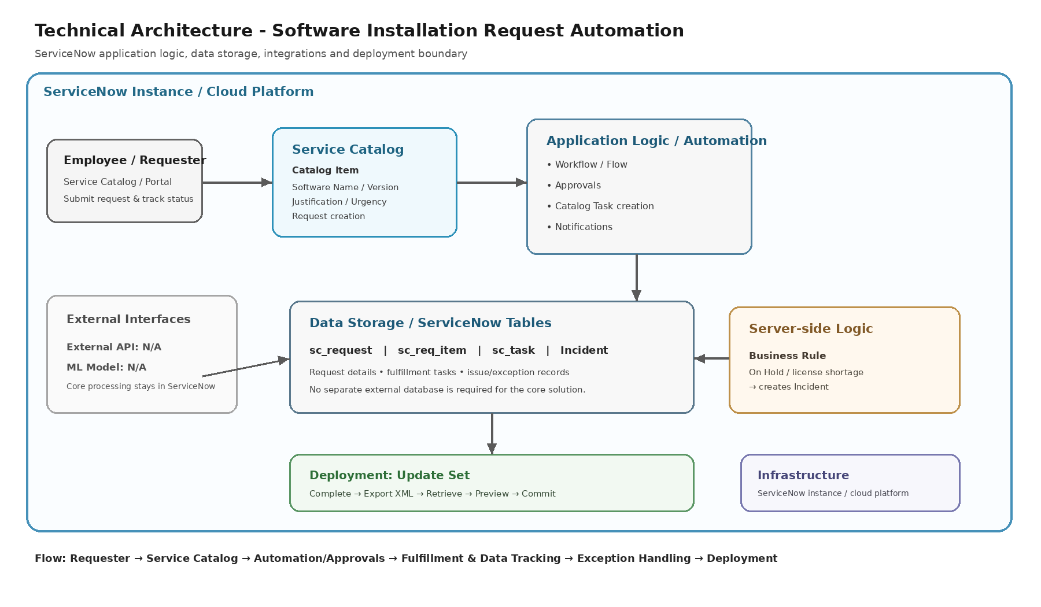

Table-1 : Components & Technologies:
S.No | Component | Description | Technology
1 | User Interface | How the user interacts with the application: Service Catalog and Service Portal request experience. | ServiceNow Service Catalog / Service Portal
2 | Application Logic-1 | Logic for software request intake, validation and request creation. | ServiceNow Catalog Item + Catalog Variables
3 | Application Logic-2 | Logic for approval and controlled request processing. | ServiceNow Workflow / Flow Automation
4 | Application Logic-3 | Logic for IT fulfillment task creation, assignment and notifications. | ServiceNow Catalog Tasks + Notifications
5 | Database | Data types and configuration records for requests and fulfillment. | ServiceNow tables: sc_request, sc_req_item, sc_task
6 | Cloud Database | Cloud database service used by the application. | ServiceNow platform data store (managed by the platform)
7 | File Storage | File storage requirements. | N/A for core project functionality
8 | External API-1 | Purpose of external API used in the application. | N/A - no external API in core solution
9 | External API-2 | Purpose of external API used in the application. | N/A - no external API in core solution
10 | Machine Learning Model | Purpose of machine learning model. | N/A - no ML model is used
11 | Infrastructure (Server / Cloud) | Application deployment environment. | ServiceNow instance / cloud platform
Local Server Configuration: N/A - the core application is configured in the ServiceNow instance.
Cloud Server Configuration: ServiceNow instance / cloud platform.
Table-2: Application Characteristics:
S.No | Characteristics | Description | Technology
1 | Open-Source Frameworks | No external open-source application framework is required for the core solution. | N/A - ServiceNow platform
2 | Security | ServiceNow authentication, roles/groups and ACL-based access control can restrict records and configuration. Approval routing provides controlled authorization. | ServiceNow Authentication, Roles/Groups, ACLs, approval controls
3 | Scalable Architecture | The solution uses platform-managed application services and table-based processing. Catalog requests, tasks and automation are separated logically by function. | ServiceNow platform, Service Catalog, Workflow/Flow
4 | Availability | The application runs within the ServiceNow instance and uses platform-managed application services rather than a self-hosted local server. | ServiceNow platform
5 | Performance | The design uses structured catalog variables, automated task creation and table-based tracking to reduce manual processing. Repeated request testing validates consistent execution. | ServiceNow Service Catalog, Workflow/Flow, server-side Business Rule
References:
https://c4model.com/
https://developer.ibm.com/patterns/online-order-processing-system-during-pandemic/
https://www.ibm.com/cloud/architecture
https://aws.amazon.com/architecture
https://medium.com/the-internal-startup/how-to-draw-useful-technical-architecture-diagrams-2d20c9fda90d

